1. OO Concepts 2
1.1 Fundamental 2
2. UML Concepts 2
2.0 UML Diagrams in different phases of projects 2
2.1 Class Diagram 2
2.2 Collaboration Diagram – (types of object interaction diagram) 4
2.4 Sequence Diagram – (types of object interaction diagram) 5
3. Requirements Modeling 6
3.1 Requirements management 6
3.2 Requirements Structure 6
3.3 Requirements Modeling 6
3.4 Requirements Modeling – Build use case diagram 7
3.5 Requirements Modeling – Create Use Case Model Survey 8
3.6 Requirements Modeling – Create Domain Object Model Diagram 8
3.7 Requirements Modeling – Describe Use Case 9
3.8 Requirements Modeling – Produce Use Case Realization Report 9
3.9 Requirements Modeling – Validate(Use Case Development Review Checklist) 9
3.10 Guide Lines for drawing Use Case in Requirements Phase 10

1. OO Concepts

1.1 Fundamental
- Encapsulation
- Relationships
  - Dependency
  - Association
  - Aggregation
  - Composition
  - Inheritance
- Polymorphism

2. UML Concepts

2.0 UML Diagrams in different phases of projects
- Inception Phase
  - Business Modeling
    - Activity Diagram
- Elaboration Phase
  - Requirements – 4.1
    - Use Case
  - Analysis & Design
    - Object/Class Diagram
    - Interaction Diagram
      - Collaboration
      - Sequence
    - State Chart

- Construction Phase
- Transition Phase

The first thing to notice about the UML is that there are a lot of different diagrams (models) to get used to. The reason for this is that it is possible to look at a system from many different viewpoints. A software development will have many stakeholders playing a part . for example: Analysts, The Customer, Technical Authors. All of these people are interested in different aspects of the system, and each of them require a different level of detail

2.1 Class Diagram
- Class name, stereotype, properties, relationship (inheritance), relationship name, role name, operations, and visibility.
- Stereotypes can be assigned for objects or class. Additional user defined types can also be used as stereotype
- Class relationship
  - Inheritance aka “is-a” relationship, solid line –I>
  - Interface aka realization
    - A relationship between a specification and its implementation class ----I>
    - A relationship between an interface and the class that provides the interface’s services
  - Client-supplier relationship aka using relationship. Where the class client uses a class supplier functions in its own operation. Uses dotted line -------->
  - Structural relationship on which one need to hold the reference of other class for a long period of time. Has Role Names and Association name and Multiplicity
    - Unidirectional
    - Bidirectional – both class hold a reference to each other
    - Aggregation(hollow diamond)/Composition(shaped diamond)
The modern approach, strongly supported by the UML is to forget all about objects and classes at the early stages of a project, and instead concentrate on what the system must be able to do. Then, as the project progresses, classes are gradually built to realize the required system functionality.

2.2 Collaboration Diagram – (types of object interaction diagram)

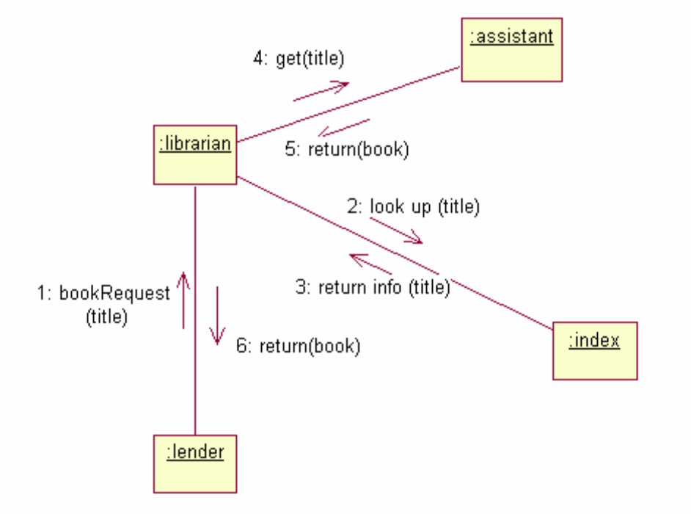
- A collaboration diagram is a type of interaction diagram that encompasses the organization of the objects that participate in the interaction
- A path is a link between objects
- Sequence no, indicates the time sequencing of messages,
- A collaboration defines the roles a set of instances play when performing a particular task (e.g. use case task)

As we are developing object-oriented software, anything our software needs to do is going to be achieved by objects collaborating. We can draw a collaboration diagram to describe how we want the objects we build to collaborate. Here is a good example of why the UML is .just. a syntax rather a true software development process. We will see that the UML notation for the diagram is simple enough, but designing effective collaborations, (that is to say .designing software which is easy to maintain and robust.), is very difficult indeed. We shall be devoting an entire chapter for guidelines on good design principles, but much of the skill in design comes from experience.

2.4 Sequence Diagram – (types of object interaction diagram)
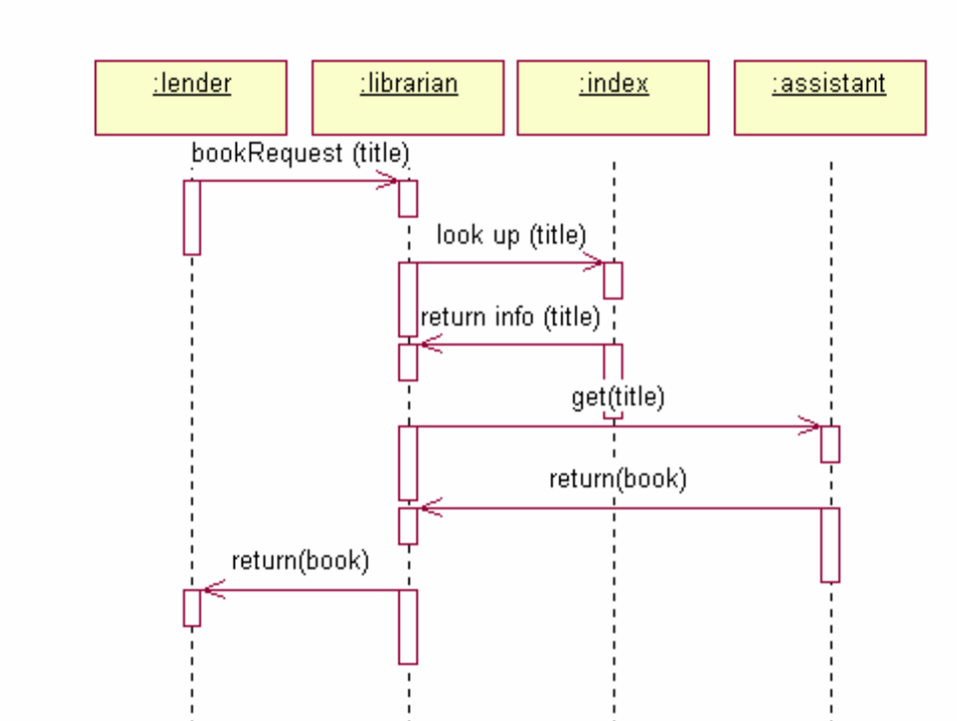
Figure 16 - A UML Sequence Diagram
The sequence diagram is, in fact, directly related to the collaboration diagram and displays the same information, but in a slightly different form. The dotted lines down the diagram indicate time, so what we can see here is a description of how the objects in our system interact over time. Some of the UML modelling tools, such as Rational Rose, can generate the sequence diagram automatically from the collaboration diagram, and in fact that is exactly how the diagram above was drawn . directly from the diagram in Figure 15.

An actor could also possibly be a more abstract concept such as time, or a specific date. For example, we may have a use case called .Purge Old Orders. in an order processing system, and the initiating actor could be .Last Working Day..

2.5 State Chart Diagram
2.5 Activity Diagram
2.5 Component Diagram
2.5 Deployment Diagram

3. Requirements Modeling

3.1 Requirements management
- A systematic approach to eliciting, organizing and documenting the requirements of the system
- Issues with managing requirements
  - Requirements have multiple sources and are seldom obvious
  - Existence of numerous types of requirements at different levels
  - Interrelationship amongst requirements
  - Conflicting requirements
  - Changing requirements
  - Gap – between the expressed and recorded/documented requirements

3.2 Requirements Structure
- Needs (problem domain) – Business motivation that drives the consideration for new features
- Feature (solution domain) – System service that fulfills some business needs
- Requirements/Use Case(solution domain) - Software capability that helps realizing some features; could be functional or non-functional

3.3 Requirements Modeling
- A formalized approach to analyzing and refining the requirements of the system
- Objectives
  - Prepare the scope of the proposed system
  - Collect, analyze and document system requirements
  - Validate system requirements
  - Provide critical input to analysis phase
  - Target correctness & comprehensives of requirements such that they can form the basis for the rest of the development phases and activities
- Steps in requirements modeling
- Use Case Modeling
  - Identify actors/use cases and associate them
  - Build use case diagrams
  - Create use case model survey
  - Identify domain objects and create object model diagram
  - Describe use cases
  - Produce use case realization reports
  - Develop logical user interface design
  - Enhance use case realization reports
- Use Case Validation
  - Develop use case instances
  - Create test cases

3.4 Requirements Modeling – Build use case diagram

- Use Cases define the scope of the System. They enable us to visualise size and scope of the entire development.
- Use Cases are very similar to requirements, but whilst requirements tend to be vague, confusing, ambiguous and poorly written, the tighter structure of
- Use Cases tend to make them far more focused The .sum. of the use cases is the whole system. That means that anything not covered by a use case is outside the boundary of the system we are developing. So the Use Case diagram is complete, with no holes.
- They allow for communication between the customer and developers (since the diagram is so simple, anyone can understand it)
- Use Cases guide the development teams through the development process . weshall see that Use Cases are the backbone of our development, and we refer to them in everything we do. We.ll see that Use Cases provide a method for planning our development work, and allow us to estimate how long the development will take
- Use Cases provide the basis for creating system tests
- Finally, Use Cases help with the creation of user guides!

It is often claimed that Use Cases are simply an expression of the system requirements. Anyone making this claim are clearly missing the point of Use Cases.

Guide Lines for drawing Use Case in Requirements Phase
- No technical terms such as Array, Variable, datatypes or database to be used. These terms could only be used during design phase. Only captured all the terms that the customer’s recognizes.

- A Use Case should satisfy a goal for the actor. Applying this simple rule to “Draw Money”. Is “take receipt” for example, the goal for our customer? Well, not really. The goal of the user is to withdraw money, and that should be the use case!

- 2 types of use case. Abstract and concrete. Abstract use case are use cases that initiated by another use case (e.g. all extends and include). Concrete – use case initiated by an actor

- It is possible for a use case to initiate communication with an actor. Textbox give this example desk officer -> rent car -> billing system. Basically used when use case need to interface with external system.

- Steps (always remember to do 1 step at a time and not to skip else it will get really confusing)

  - Identify use case (in its most granular form, could also classify them into primary and secondary tasks) , identify actors, associate them
  - Determine is there is a need to break them down into several use case (check the question weightage)
  - Generalize actors/use case (details that are missing due to generalization can be describe use case description)
    - Generalize actors by using abstract actors e.g. Both user and administrator could view records.
    - Generalize use case e.g. use case check password and fingerprint can be generalized into validate user
  - Reuse common use case (refactor) use case(using include) e.g. update records must include use case login
  - Enhance/extend. E.g. Update records may extend search records
  - Draw system boundary
  - If required, rank the use cases

3.5 Requirements Modeling – Create Use Case Model Survey

Content of Use Case Model Survey
- Introduction
  - A brief description about the proposed system, thereby establishing the boundary, scope and other high level details
- Survey Description
  - An Overview of the use cases and actor relationships
- Actors
  - List of actors with brief role description
- Use Cases
  - Brief description of use cases with their purpose and events associated with them either as a bulleted list of paragraphs
- Use case global view diagram
  - Depiction of actor and use case interactions

3.6 Requirements Modeling – Create Domain Object Model Diagram
- A model illustrating how the real world objects interact in the system (could be optional in use case modeling)

- Ideally there should be one set of domain object model diagrams per use case

- 2 Types of Object Model Diagram.

  - [1] Static Perspective – Class Diagram. Aka static relationships between domain objects
  - [2]Dynamic Perspective – Collaboration/Sequence Diagram. Aka dynamic interactions among domain objects

- Guideline to Domain Object Model Diagram
  - Do not start assigning multiplicities to associations
  - Do not assign operations to domain objects
  - Ensure that all domain objects identified is sufficient for the specified use case to execute

3.7 Requirements Modeling – Describe Use Case

1 | Use Case Name | A short name that aptly tells the reader what the use case does
2 | Actors | List of actors involved in the use case
3 | User case brief | A short narrative description of the use case itself
4 | Trigger | Event/ events that trigger the use case. This helps to capture the cause(s) of the of the use case (business activity)
5 | Preconditions | Constraints on the state of the system before the use case can be triggered
6 | Flow of events | Sequence of activities that occur as the actors and the system attempt to accomplish the goal. This is written as a series of narrative steps.  *focus on user interactions and usage scenarios. Not functional requirements
7 | Alternative flows | Sequence of the activities that are triggered if and only if the main seuqnce aka main flow have exceptions
 | Exception flows | A description of possible alternate interaction
8 | Post condition | Constraints on the state of the system after the use case has successfully completed
9 | Features | The features and functionalities that are identified from the requirements description
10 | Related Use Cases | The use cases that are related to this use case are captured. Typically include all “include” and “extend” use cases
11 | Logical Screen order | This depicts the logical transaction flow of how the use would be enacted
* Possible to supplement complicated flow of events with activity diagram

3.8 Requirements Modeling – Produce Use Case Realization Report

1 | Use case description report
2 | Interaction Diagram | Collaboration diagram
3 | Participating Objects | Brief description of each objects shown in the interaction
4 | Class diagram | Static relationships of participating objects.
5 | Derived requirements | Requirements not captured by the flow of events, such as operational environment, performance, quality

3.9 Requirements Modeling – Validate(Use Case Development Review Checklist)
- System scope
  - The business case for the system is clear and understood by all stakeholders
- Identified Actors
  - All external entities(actor) interacting with the system have been identified
  - All actors are entities external to the system
- Identified use case
  - Use cases encompasses all requirements
  - All assumption about the use case are documented
  - Extend behaviors are not alternate flows or exceptions
  - Common behavior is factored out as includes relationship
- Diagramming Use case
  - All diagramming conventions are followed
  - Use case are organized in such a way that they are amenable to modularity in later stages

3.10 Guide Lines for drawing Use Case in Requirements Phase
- No technical terms such as Array, Variable, datatypes or database to be used. These terms could only be used during design phase. Only captured all the terms that the customer’s recognizes.

- Only interested in the attributes of the class (during requirements phase)

- If in doubt whether to put it as an attribute or class. Then to be safe, put as class. For example salary can be an attribute of an employee but also a class.

- If the property of an object cannot do any operation most lightly it will be an attribute

- Steps

  - Draw all classes (don’t link them, don’t give cardinality until this step is done)
  - Do we need inheritance in class diagram during requirements ????
  - Do we need association in class diagram during requirements ????
  - Do we need composite/aggregation in class diagram during requirements ????
  - Link/associate the class(don’t give cardinality until this step is done)/ give role name
  - Give cardinality
  - Write important attributes

4. Analysis Modeling
Use Case Model
(include domain modelling)
Analysis Model
(High level requirements, Focus on businesses requirements)
Design Model
(detailed requirements, Focus on system requirements)

Analysis Objects
- Boundary Objects
  - Functions are dependent on system environment
  - Model interaction between system and actors
  - 2 Types
    - Object
- Entity Objects
  - Contains the information that will be passed among object or to be kept for a long period of time
- Control Objects
  - Handle Behavior dimension of the systems

DESIGN
- Design Modeling
  - Design Modeling - 1, Design Principles
  - Design Modeling - 2, Software Architecture
  - Design Modeling - 3, Design Activities
  - Design Modeling - 4, Design Deliverables, Artifacts and Process
  - Design Modeling – 5, Design for persistency
  - Design Modeling – 6, Model-driven Architecture
  - Design Modeling – 7, Agility vs. Architecture
- Implementation Model
  - Refactoring
  - Documenting Code
  - Implementing Design Model

Design Modeling - 3, Design Activities

- Design activities concerns
  - Programming language and environment
  - Architectural components such as networking, databases and external systems
  - Splitting into subsystems and interfaces
  - Redefining use case dynamics using sequence diagram
  - Improve object structure by using framework and patterns

- Typical activities involved when transiting from analysis to design
  - Convert analysis objects to design objects. Done by giving objects more concrete and complete attribute and behaviors
  - Structure according architecture decision
    - Chosen programming language
    - Chosen libraries
    - Chosen persistence model
    - Interfaces to to external system
  - Model detailed dynamic behaviour
    - Sequence diagram
  - Refine object structure
    - Design patterns
    - Review operations, attributes roles and purposes of class – using class diagram
      - Identify affected classes, appropriately modify the classes and verify modified model against requirements and use cases

- Database persistent

2.1 Part of architecture application is to define how data will be persisted to secondary storage. DBMS typically provide
- A logical vie of the data
- A query-based access mechanism for creation, modification and deletion of data
- Concurrency and recovery for database transaction
- Access control

  - Database Mapping for entity objects
- Mapping – relational modelfs are often similar to domain object where the domain objects can be mapped to tables and the attributes in domain object can be mapped to fields and instances of the domain objects can be mapped as records
- Mapping issues –
SN | Object Model | RDMS
1 | Reference to instances is via ram location. usually temporary and internal | Reference to instances is via primary key. Fixed and unique
2 | Attributes can be any data type e.g. another class object | Fields could only use primitive types
3 | Object contain behaviors | Table contains pure data.
4 | Inheritance is naturall and built into the programming model | Inheritance is difficult to implement and not necessarily efficient
5 | Runtime object population limited by the amount of RAM | RDBMS can store huge number of records

  - Persistent - Design Question
- Where SQL statements should resides. Directly in entity objects or through a DB controller
- Do you need to store primary keys in instances
- How many instances in the run time are required? Do they have to be shared(e.g. static or singleton)
- Are the database shared ? do we need to lock the records or tables ?
- Design for objects
  - Assign 1 table per class and 1 per relationship
  - Primitive attribute become one column
  - Complex attribute will be broken in to primitive columns in same table or separated table(depends whether is a collection a not)
  - Structured table as appropriate to model inheritance
  - Perform normalization to avoid redundancy
- Design for performance
  - Review table index, data types and redundancy
  - Denormalize may sometimes help performance
  - Avoid SP as they are not portable and not modeled
- Or use a DAO framework. E.g. Castor or JDO,. DAO design patterns/framework could help to decouple RDBMS layer from object model

- Connecting to external systems (fill up later)
- Subsystem (fill up later)
- Use Case Dynamics
- Define the dynamic and static behavioral aspects of the design in details
  - Start by assigning one design operation for each analysis operation – then refine the operation as necessary
    - Operation need to be documented. Provide a short description for each operations and explain clearly the objective of the function and dynamics
    - Specify input parameters in the parameter section of each operation
    - Specify the return type of the operation
  - Descriptions above should become API documentation -> can be done via java doc
  - Review object operations based on “retelling” the flows of events of the use cases. You need to account for New design objects and modified relationships
- Document the flow of events by means of Sequence Diagram
  - Analyze the date flow in the Use Case, defining parameters and return types for operations
  - analyze instance creation requirements
  - Update attributes and operations as needed
- Transforming composition objects
  - Often composite objects need to communicate with each other
  - There are 2 approaches
    - Object creation association – The creating object passes a reference to itself to the constructor
    - Main control object- create several other objects and pass their references as needed
- Object Structure Improvements
  - Objects must be reviewed for flexibility, extensibility, maintainability (high cohesiveness and loose coupling)
  - Knowledge of design patterns is crucial
  - Later design changes (refactoring) are possible by applying design patterns
  - Object coupling
    - is the degree (strength) of interrelationship between objects
    - Unnecessary tight coupling of objects make the system more difficult to change, reducing reusability
  - Object cohension
    - How logically related the components of the external view of an object are
    - Cohesive objects are “single minded” and more stable
  - System with cohesive objects and loose coupling are easier to develop, understand and maintain

Design Modeling - 4, Design Deliverables, Artifacts and Process

4.1 Design Deliverables

- Design model reports (Describe the design model in single document, comprising)
  - A description of transition from analysis to design
  - Package diagram(s)
  - Class diagrams(s)
  - Component Diagram(s)
  - Deployment Diagram(s)
- Use Case realization report
  - Describe selected use cases, 1 report per use case
  - Each UCRR should include flow of events, seuqnce diagrams and class diagrams
  - Only for use cases that change substantially during the transition from analysis to design
- Class Report (Design) – optional
  - specify each design object (1 report per design class)

4.2 Design UML diagram
- Sequence diagrams and collaboration diagram (aka interaction diagram)
  - Describes the interaction between objects for individual flows of events/OR use cases
  - Each use case draw at least 1 sequence, (when necessary draw several)
  - Describes flow of events in use cases are realized as communications between instances
- Class diagrams
  - Describe the object structures introduced/modified during design
- Packaging Diagrams
  - Describe the relationship between packages
- Component Diagrams
  - Describe assembly/packaging strategies
- State chart diagrams
  - Describe stat transitions within a class, for objects with complex behavior

4.3 Model Driven Architecture
- MDA is a model-based, standards-driven and tool supported software engineering approach to application and software system development
- Key concepts
  - Platform independent vs platform specific models
  - Model mapping and metamodels
  - Automatic transformation
- MDA Elements and Transoformation
  - Computation Independent Model – Business requirements Modelling
  - Platform Independent Model - Analysis
  - Platform Specific Model – Design
  - Code - Implementation
  - (CIM)-> (PIM) -> (PSM) -> (Code)

